|  |  |
| --- | --- |
| Student Name | Asadullah |
| Roll Number | 21SW036 |
| Section # | 03 |
| Lab # | 02 |

**Task#01**

Question statement

The contact app on our phone contains a lot of contacts. In ContactApp(class) perform the following operations:

Display all contact

Search a contact //name -> number

Add a new contact // name, number , pos/index

Update the contact //name1, name2

Delete any contact //

NOTE: Create a 2D array of string type.

# ContactApp.Java

**Code:**

import java.util.Scanner;  
public class ContactApp{  
 Scanner sc = new Scanner(System.*in*);  
  
 public void displayChoices(){  
 System.*out*.println("0. Exit");  
 System.*out*.println("1. Display contacts");  
 System.*out*.println("2. Search contacts");  
 System.*out*.println("3. Add contacts");  
 System.*out*.println("4. Update contacts");  
 System.*out*.println("5. Delete contacts\n");  
 }  
 public void displayContacts(String [][] arr){  
 System.*out*.print("[");  
 for(int i=0; i<arr.length; i++){  
 if (i!=arr.length-1){  
 System.*out*.print("["+arr[i][0]+", "+arr[i][1]+"], ");  
 } else {  
 System.*out*.print("["+arr[i][0]+", "+arr[i][1]+"]");  
 }  
 }  
 System.*out*.print("]\n");  
 } // end of displayContacts() method  
  
 public void searchContact(String [][] arr){  
 System.*out*.print("Enter contact name or number to search in list: ");  
 String contact = sc.nextLine();  
 for(int i=0; i<arr.length; i++){  
 if(arr[i][0].equals(contact) || arr[i][1].equals(contact)) {  
 System.*out*.println(contact+" found at index ["+i+"][0]");  
 return;  
 }  
 }  
 System.*out*.println(contact+" is not present in Contacts");  
 } // end of searchContact() method  
 public String[][] addContact(String [][] arr){  
 String [][] newArray = new String[arr.length+1][2];  
 int size = newArray.length;  
 System.*out*.print("Enter new contact name: ");  
 String contact = sc.nextLine();  
 System.*out*.print("Enter new contact number: ");  
 String number = sc.nextLine();  
 System.*out*.println("Enter position(from 1 to "+size+") to add at: ");  
 size++;  
 int pos = sc.nextInt();  
 sc.nextLine();  
 for (int i=pos-1; i< newArray.length-1; i++){  
 newArray[i+1] = arr[i];  
 }  
 for (int i=0; i< pos-1; i++){  
 newArray[i] = arr[i];  
 }  
 // because index = pos - 1; e.g(pos = 7, then index = 6, pos = 1, index = 0)  
 newArray[pos-1][0] = contact;  
 newArray[pos-1][1] = number;  
 System.*out*.println(contact+" added in list");  
 return newArray;  
 } // end of addContact() method  
  
 public void updateContact(String [][] arr){  
 System.*out*.println("Enter contact name to update: ");  
 String oldName = sc.nextLine();  
 System.*out*.println("Enter new name: ");  
 String newName = sc.nextLine();  
 System.*out*.println("Enter new number: ");  
 String newNumber = sc.nextLine();  
 int index = 0;  
 for (int i=0; i< arr.length; i++){  
 if(arr[i][0].equals(oldName)){  
 index = i;  
 break;  
 }  
 } // end of for loop  
 arr[index][0] = newName;  
 arr[index][1] = newNumber;  
 } // end of updateContact() method  
 public String[][] deleteContact(String [][] arr){  
 System.*out*.print("Enter contact name to delete: ");  
 String contact = sc.nextLine();  
 int size = arr.length;  
 String [][] newArray = new String[arr.length-1][2];  
 if(arr[size-1][0].equals(contact)){  
 for (int i=0; i< arr.length-1; i++){  
 newArray[i][0] = arr[i][0];  
 newArray[i][1] = arr[i][1];  
 }  
 } else {  
  
 int index = 0;  
 for (int i = 0; i < arr.length - 1; i++) {  
 if (arr[i][0].equals(contact)) {  
 index = i;  
 }  
 } // end of for loop  
 for (int i = 0, k = 0; i < newArray.length; i++) {  
 if (i == index) {  
 continue;  
 }  
 newArray[k][0] = arr[i][0];  
 newArray[k][1] = arr[i][1];  
 k++;  
 } // end of for loop  
 newArray[newArray.length - 1][0] = arr[arr.length - 1][0];  
 newArray[newArray.length - 1][1] = arr[arr.length - 1][1];  
 }  
 System.*out*.println(contact+" deleted from list");  
 return newArray;  
 } // end of deleteContacts()  
  
 public static void main(String[] args) {  
  
  
 String [][] contacts = {{"Asad", "+924567891237"}, {"Awais", "+924512345789"}, {"Junaid", "+924513687002"}, {"Sir Mohsin", "+9245136789010"}, {"Abbas", "+924123678410"}, {"Uzair Hussain", "+921345689698"}, {"Hassan", "+928746555445"}, {"Waryal", "+924513789456"}};  
 ContactApp ca = new ContactApp();  
  
 Scanner sc = new Scanner(System.*in*);  
 int choice;  
 do{  
 ca.displayChoices();  
 System.*out*.println("Enter your choice: ");  
 choice = sc.nextInt();  
 switch (choice){  
 case 0-> System.*exit*(0);  
 case 1 -> ca.displayContacts(contacts);  
 case 2 -> ca.searchContact(contacts);  
 case 3 -> contacts = ca.addContact(contacts);  
 case 4 -> ca.updateContact(contacts);  
 case 5 -> contacts = ca.deleteContact(contacts);  
 default -> System.*out*.println("Invalid, please select correct option");  
 }  
 } while (choice!=0);  
  
 }  
}

**Output:**

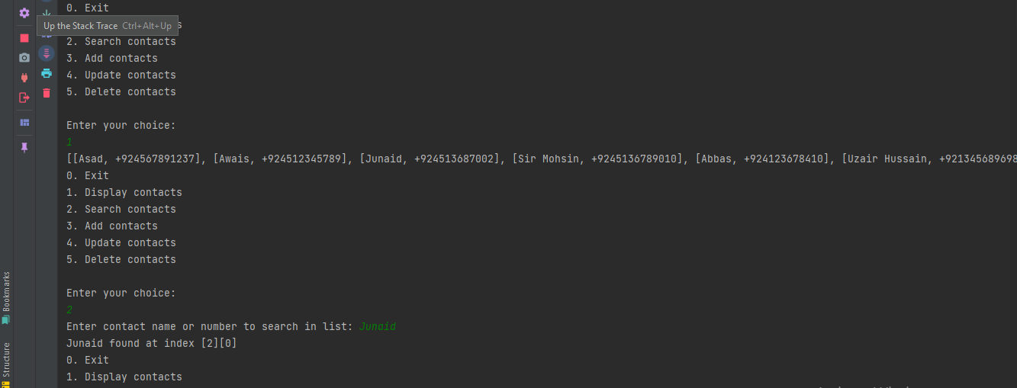

# 

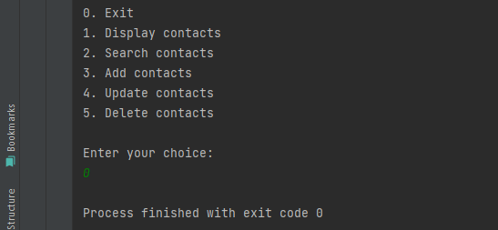

**Task#02**

Question statement

The Music app name is FireAir(class) musicapp which can perform following functions

print all the array songs/music names one by one.

Adds new songs/music.

Deletes a song/music using the number.

Searches song/music using a number or by the name.

Update song/music (index, value)

# FireAir.Java

**Code:**

import java.util.Arrays;  
import java.util.Scanner;  
  
public class FireAir{  
  
 Scanner sc = new Scanner(System.*in*);  
 public void displayChoices(){  
 System.*out*.println("0. Exit");  
 System.*out*.println("1. Display songs");  
 System.*out*.println("2. Search songs");  
 System.*out*.println("3. Add songs");  
 System.*out*.println("4. Update songs");  
 System.*out*.println("5. Delete songs\n");  
 }  
  
 public void displaySongs(String [] arr){  
 System.*out*.print("[");  
 for(int i=0; i<arr.length; i++){  
 if(i==arr.length-1){  
 System.*out*.print(arr[i]);  
 } else {  
 System.*out*.print(arr[i] + ", ");  
 }  
 }  
 System.*out*.print("]\n");  
 } // end of displaySongs() method  
  
 public void searchSong(String [] arr){  
 System.*out*.print("Enter song to search: ");  
 String song = sc.nextLine();  
 for(int i=0; i<arr.length; i++){  
 if(arr[i].equalsIgnoreCase(song)){  
 System.*out*.println(song+" found at index " + i);  
 return;  
 }  
 }  
 System.*out*.println(song+" is not present in Playlist");  
 } // end of searchSong() method  
  
 public void updateSong(String [] arr){  
 System.*out*.print("Enter index to update: ");  
 int index = sc.nextInt();  
 sc.nextLine();  
 System.*out*.print("Enter new song: ");  
 String newSong = sc.nextLine();  
 arr[index] = newSong;  
 } // end of updateContact() method  
  
 public String[] addSong(String [] arr){  
 System.*out*.print("Add new song to playlist: ");  
 String song = sc.nextLine();  
 String [] newArray = new String[arr.length+1];  
 for (int i=0; i< newArray.length-1; i++){  
 newArray[i] = arr[i];  
 }  
 newArray[newArray.length-1] = song;  
 return newArray;  
 } // end of addSong() method  
  
 public String[] deleteSong(String [] arr){  
 System.*out*.print("Enter index of song to delete: ");  
 int index = sc.nextInt();  
 int size = arr.length;  
 String [] newArray = new String[arr.length-1];  
 if(size-1==index){  
 for (int i=0; i< newArray.length; i++){  
 newArray[i] = arr[i];  
 }  
 } else {  
 for (int i = 0, k = 0; i < newArray.length; i++) {  
 if (i == index) {  
 continue;  
 }  
 newArray[k++] = arr[i];  
 } // end of for loop  
 newArray[newArray.length - 1] = arr[arr.length - 1];  
 }  
 return newArray;  
 } // end of deleteSong()  
  
 public static void main(String[] args) {  
  
 String [] songs = {"Applause", "Tennis Court", "Days Go by"};  
 FireAir fa = new FireAir();  
  
 Scanner sc = new Scanner(System.*in*);  
 int choice;  
 do{  
 fa.displayChoices();  
 System.*out*.println("Enter your choice: ");  
 choice = sc.nextInt();  
 switch (choice){  
 case 0-> System.*exit*(0);  
 case 1 -> fa.displaySongs(songs);  
 case 2 -> fa.searchSong(songs);  
 case 3 -> songs = fa.addSong(songs);  
 case 4 -> fa.updateSong(songs);  
 case 5 -> songs = fa.deleteSong(songs);  
 default -> System.*out*.println("Invalid, please select correct option");  
 }  
 } while (choice!=0);  
  
  
  
 }  
}

**Output:**

